WADHWANI FOUNDATION | Entrepreneur



**ACTIVATE**

**Milestones**

**01**

WADHWANI FOUNDATION | Entrepreneur



# INTRODUCTION AND TEAM COMPOSITION

# Business Name: ! DO KNOW PV ID:

|  |  |  |
| --- | --- | --- |
| **Team members names** | **Strengths and abilities** | **Role/Position** |
| Tarun Kotagiri | Growth mindset, Confident. | CEO |
| G. Vivek | Strategic planning, Innovative thinking, | COO/CTO |
| P. Sushma |  | CFO/CMO |

**What makes us a good team to solve the problem we chose?**

We share a common goal of improving the education style and making an impact on the STUDENT life. All of us work hard towards our aligned goal, We offer each other support, We communicate well with each other, We have fun working together.

**02** Creating Jobs. Changing Lives.

WADHWANI FOUNDATION | Entrepreneur



# PROBLEM STATEMENT CANVAS

All the LEARNERS need a strong visual clarity of the concepts they learn to completely understand a system. Our Mind thinks and remembers visually. Even the text we read is saved in our brains visually. Strong visuals also contribute to long term memory. But people often find themselves in the abyss when they realize what they imagined isn’t quite close to the real thing. It’s hard to associate the correct working mechanism to the one we make up with our existing heap of visuals.

Addressing this problem will ensure that learners get hold of 100% of the information they’re trying to learn and moreover in the CORRECT way. Addressing this problem will be a game changer in the entire world. Learners across the world include students, Instructors, working professionals, and many individuals as well.. as learning is a life long process. So modifying the way we learn will be a HUGE impact on the world. Better learning methodology boosts learner’s Interest, Motivation and limitless learning unlocks the true potential in ONE as there will be nothing holding him back from the TRUE and CORRECT knowledge.

**02**

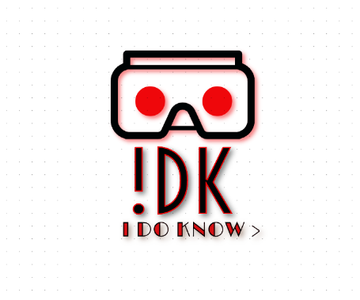

**Place your logo here**

Creating Jobs. Changing Lives.

WADHWANI FOUNDATION | Entrepreneur



# CUSTOMER

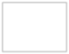

**Place your**

|  |
| --- |
| **Results** |
| What is your Market type? ED TECH |
| What is your TAM - Total Addressable Market? q |
| What is your SAM – Serviceable Addressable Market? q |
| What is your SOM – Serviceable Obtainable Market? q |
| What is your Niche? q |

**02**

Creating Jobs. Changing Lives.

WADHWANI FOUNDATION | Entrepreneur



## RESULTS OF THE SURVEY:

## 

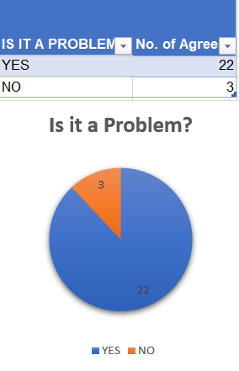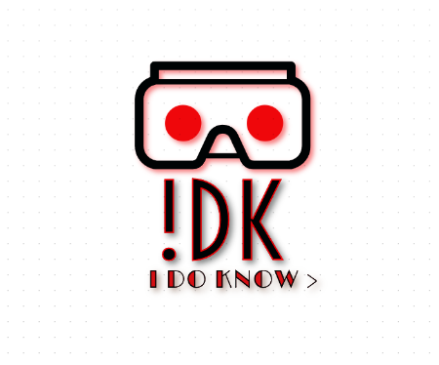



**Place your logo here**

|  |
| --- |
| **Results** |
| How many customers did you interview? (At least 25 for B2C and 2 for B2B) B2C - 25 |
| How many of them agree this is a problem that needs to be solved? 22 |
| How many of them said they can already solve this problem and don't need a new solution? |

**02**

Creating Jobs. Changing Lives.

WADHWANI FOUNDATION | Entrepreneur



## CUSTOMER PERSONA (PRESENT CUSTOMER PERSONA FOR ALL CUSTOMER SEGMENTS)



**Place your logo here**

Attribute 1

Attribute 2

Attribute 3

**Goals**

**Insert your customer’s picture/photo**

* + **?**
  + **?**
  + **?**

How does your customer describe herself in a few words or 1 line?

* + **? Frustrations**
  + ?
  + ?

Age (in years): Gender: Profession: Location:

* + ?

**Motivations**

**Personality**

**Bio**

* Describe in brief about your customer?
* Try to explain in not more than 8 lines or 2 paragraphs

Creating Jobs. Changing Lives.



Thank You!